HOUSING AUTHORITY OF THE
TOWN OF HARRISON

REQUEST FOR PROPOSALS

MODERNIZATION CONSULTANT SERVICES

Under a Fair and Open Process in Accordance
with N.J.S.A. 19:44A-20.4 et seq.

PROPOSALS MUST BE SUBMITTED BY

October 28, 2025

To:

Raymond Lucas, Executive Director
Housing Authority of the Town of Harrison
788 Harrison Avenue, Building #1
Harrison, New Jersey 07029

Advertisement

Proposals for Modernization Consultant Services will be received by the Housing Authority of the Town of Harrison (“Housing Authority”) at 788 Harrison Avenue, Building #1, Harrison, New Jersey 07029, until October 28, 2025.

The Request for Proposals (“RFP”) can be obtained via email to the Housing Authority’s Principal Account Clerk, Edward Azevedo, at nazevedo@harrisonhousing.com.

All proposals shall be submitted in a sealed envelope, labeled “Proposal for Modernization Consultant Services” and including the respondent’s company name and return address. The envelope must contain a printed copy of the entire proposal and a flash drive containing a PDF copy of the entire proposal. Respondents must ensure that their proposal is received at the address and by the deadline specified above. Proposals received after the deadline for any reason shall not be considered and will be returned to the sender.

All responses submitted are subject to these instructions and to the Instructions to Offerors, Non-Construction form HUD-5369-B. The failure to abide by these instructions in any way, including but not limited to the failure to submit all required documentation, may lead to the proposal being rejected as non-responsive.

The Housing Authority reserves the right to reject any and all proposals and/or to waive any informality in the responses. No proposals may be withdrawn within sixty (60) days after the submission deadline.

In accordance with the criteria included in the RFP, the contract shall be awarded to the respondent who submits the proposal most advantageous to the Housing Authority, cost and other factors considered. The successful respondent will be required to execute the Housing Authority’s contract within seven (7) days of receiving the notice of award.

This RFP is being issued pursuant to a fair and open process in accordance with N.J.S.A. 19:44A-20.4 et seq.
TABLE OF CONTENTS

Proposal Instructions
- Purpose
- Terms and Conditions
- Scope of Services
- Qualifications
- Proposal Requirements
- Submission Requirements
- Evaluation Criteria
- Americans with Disabilities Act Language
- Mandatory Affirmative Action Language

Proposal Documents
- Proposal Checklist
- Acknowledgment of Addenda
- Fee Proposal Form
- Qualifications Statement
- Affirmative Action Compliance Notice
- HUD-5369-B
- HUD-5369-C
- Disclosure of Investment Activities in Iran
- Certification of Non-Involvement in Russia or Belarus

Contract Documents
- Form of Contract

1. PURPOSE

The Housing Authority of the Town of Harrison (hereinafter called “Housing Authority” or “HHA”) is a public housing agency with administrative offices located at 788 Harrison Avenue, Building #1, Harrison, New Jersey 07029. The Housing Authority provides quality, affordable housing to low-income families and seniors through its Public Housing program.

In accordance with applicable Federal and State of New Jersey requirements, the Housing Authority is currently accepting proposals for Modernization Consultant Services for a term of one (1) year. The Modernization Consultant must be available to provide services to the Housing Authority during normal business hours and off-business hours as needed. The Modernization Consultant shall not have any conflicts that would interfere with performing this scope of service during normal business hours and/or off-business hours as needed.

All services must be provided in accordance with applicable Federal, State of New Jersey, and local statutes, rules, regulations, ordinances, orders, and codes (including the rules, orders, directives, and regulations promulgated by the U.S. Department of Housing and Urban Development (“HUD”)).

All proposals shall be reviewed for completeness and shall be analyzed in accordance with the criteria contained herein. Therefore, the Housing Authority urges all interested firms to carefully review the requirements of the RFP, including the attached Instructions to Offerors (HUD-5369-B). Failure to abide by the RFP’s instructions in any way may lead, in the Housing Authority’s sole discretion, to the rejection of the proposal as non-responsive.

2. TERMS AND CONDITIONS

Any requests for clarification as to the meaning of any provision of this Request for Proposals shall be submitted in writing no later than October 28, 2025 via email to the Housing Authority’s Principal Account Clerk, Edward Azevedo at nazevedo@harrisonhousing.com. If deemed necessary by the Housing Authority, an addendum will be issued to all individuals who were issued a copy of the Request for Proposals. Any prospective respondent obtaining the RFP from the Housing Authority website shall be responsible for ensuring they are aware of any addenda to the RFP by verifying such with the Housing Authority prior to submission. Failure of any proposer to receive any such addendum shall not relieve them from an obligation under their proposal as submitted.

All proposals shall remain valid for a period of sixty (60) calendar days after the date specified for receipt of proposals. All costs of the proposal process, interviews, and related expenses, are solely the responsibility of the respondent.

The Housing Authority reserves the right to reject any or all proposals, to waive informalities and minor irregularities, and/or modify or cancel this Request for Proposals. Proposals which appear unrealistic in terms of management commitments or are indicative of failure to comprehend the complexity of this RFP and subsequent contract may be rejected.

Respondents are requested and advised to be as complete as possible in their response. The Housing Authority reserves the right to 1) contact any respondent to clarify their proposal; 2) contact any past/current clients of the respondent; 3) solicit information from any available source concerning any aspect of the proposal; and 4) seek and review any other information deemed pertinent to the evaluation process.

3. SCOPE OF SERVICES

The successful respondent shall provide the full scope of Modernization Consultant services required for the proper administration of the Housing Authority’s Capital Fund program (“CFP”). These services shall be provided subject to the oversight and approval of the Housing Authority’s Executive Director. The scope of services shall not include legal compliance or contracts. The scope of services shall include, but not be limited to:

- Provide technical assistance in all aspects of the management of the CFP, including but not limited to:
- Procurement processes.
- Assist with responses to HUD reviews, REAC, EPIC, audits and general correspondence involving modernization and/or the CFP.

- Assist in the development of an overall plan and time table for implementation of approved modernization programs, including physical and management improvements.

- Assist in administrative controls over key incoming and outgoing documents and Authority activities related to the CFP.

- Prepare the Annual Statement and Progress and Evaluation Reports for all open CFP grants.

- Assist in updating the Five-Year Plan (yearly).

- Assist in preparation of the mandated PHA Annual Plan and Five-Year Plan.

- Prepare all CFP budget revisions required for actual expenditures.

- Prepare all HUD close-out documents for each CFP (actual Modernization Cost Certificate and Final Progress and Evaluation Report).

- Prepare ELOCCS requests for staff drawdown.

- Update (monthly) Capital Fund Program budgets for submittal to Executive Director.

- Perform any additional related duties as required and directed.

4. QUALIFICATIONS

Respondents shall meet the following minimum requirements:

- Is authorized to do business in the State of New Jersey.

- Is capable of providing the requested scope of services in accordance with the requirements set forth herein.

- Has demonstrated knowledge of the latest HUD rules and regulations on Capital Funds, including but not limited to obligation and expenditure requirements, and eligible activities.

- Has hands-on experience with public housing modernization, including but not limited to the Capital Fund program, the EPIC system, and the eLOCCS system.

- Is able to truthfully and accurately provide all information required on the Qualifications Statement.

- Is approvable by HUD.

Failure to meet any of the foregoing qualifications is considered a material defect and shall result in the disqualification of the Respondent.

5. PROPOSAL REQUIREMENTS

- Proposals shall be submitted on the company letterhead, and signed by the owner or an executive officer of the firm.

- Narrative – Provide a narrative description of the respondent’s business and proposed services, which shall include the following elements:

      - Executive Summary – Provide a brief non-technical overview of the Respondent’s business including the range of services offered. Respondents should demonstrate how and why their services meet the Housing Authority’s needs and qualification requirements.

      - Company Profile – Provide a history of the business and resumes of key staff to be involved in all aspects of the Modernization Consultant services. This shall include both the company’s history providing Modernization Consultant services generally, as well as its experience providing such services to public housing authorities.

      - Proposed Services – Describe in detail each aspect of the modernization consultant services proposed.

      - Proposed Fees – Provide a flat fee for the performance of the services described herein and an hourly rate for any additional services outside the scope of services described herein. The Housing Authority shall not reimburse or otherwise pay for any travel-related expenses. The Housing Authority shall reimburse for the cost (including 10% markup) of materials used in providing the requested services. Invoices shall be accompanied by reliable proof of the actual cost of materials.

- Required Documentation – Respondents shall submit a printed copy and a flash drive containing a PDF copy of their proposal, including the enclosed checklist and all documentation identified therein. Failure to provide any of the required documentation at the time of submission may be considered a fatal defect warranting rejection of the proposal.

- Insurance – Respondents shall possess the insurance coverages specified on the Qualifications Statement. The premium cost of all insurance purchased by the Respondent for protection against risks assumed by virtue of the contract shall be borne by the Respondent and is not reimbursable by the Housing Authority. The Housing Authority specifically reserves the right to require the Respondent to provide certified copies of any and all insurance policies.

6. SUBMISSION REQUIREMENTS

Proposals must be received by the Housing Authority at the below address by October 28, 2025 at 12:00 p.m. in a sealed envelope clearly marked and labeled as follows:

Name of Respondent
Respondent’s Return Address
Proposal for Modernization Consultant Services
DUE DATE: [October 28, 2025 at 12:00 p.m.

ATTN: Raymond Lucas, Executive Director
Housing Authority of the Town of Harrison
788 Harrison Avenue, Building #1
Harrison, New Jersey 07029

Proposals must be submitted by mail, hand delivery, or courier service such as Fed Ex or UPS only. No faxed or emailed proposals shall be accepted. Respondents must ensure that their proposal is received at the address and by the deadline specified above. Proposals received after the deadline for any reason shall not be considered and will be returned to the sender.

7. EVALUATION CRITERIA

- All proposals will be reviewed in accordance with the below evaluation criteria.

Evaluation Criteria | Weighting (Maximum Points)
Demonstrated hands-on experience with public housing modernization, including but not limited to the Capital Fund program, the EPIC system, and the eLOCCS system. | 30
Familiarity with the latest HUD rules and regulations on Capital Funds, including but not limited to obligation and expenditure requirements, and eligible activities. | 30
Capability and capacity to accomplish quality work within the required time period | 20
References from current or former clients, particularly N.J. Public Housing Authorities | 10
Reasonableness of proposed fee(s) | 10
TOTAL | 100

- The Housing Authority reserves the right to waive any informality and to reject any and all proposals. No Proposal may be withdrawn for sixty (60) days after the due date. Proposals may be withdrawn prior to the due date either in person or by mail.

- The contract shall be awarded to the respondent who submits the proposal most advantageous to the Housing Authority, cost and other factors considered.

- The successful respondent shall be required to execute the Housing Authority’s contract(s) within seven (7) days of receiving the notice of award.
AMERICANS WITH DISABILITIES ACT OF 1990
Equal Opportunity for Individuals with Disability

The contractor and the Housing Authority of the Town of Harrison (hereafter “owner”) do hereby agree that the provisions of Title II of the Americans With Disabilities Act of 1990 (the "Act") (42 U.S.C. 12101 et seq.), which prohibits discrimination on the basis of disability by public entities in all services, programs, and activities provided or made available by public entities, and the rules and regulations promulgated pursuant there unto, are made a part of this contract. In providing any aid, benefit, or service on behalf of the owner pursuant to this contract, the contractor agrees that the performance shall be in strict compliance with the Act. In the event that the contractor, its agents, servants, employees, or subcontractors violate or are alleged to have violated the Act during the performance of this contract, the contractor shall defend the owner in any action or administrative proceeding commenced pursuant to this Act. The contractor shall indemnify, protect, and save harmless the owner, its agents, servants, and employees from and against any and all suits, claims, losses, demands, or damages, of whatever kind or nature arising out of or claimed to arise out of the alleged violation. The contractor shall, at its own expense, appear, defend, and pay any and all charges for legal services and any and all costs and other expenses arising from such action or administrative proceeding or incurred in connection therewith. In any and all complaints brought pursuant to the owner’s grievance procedure, the contractor agrees to abide by any decision of the owner which is rendered pursuant to said grievance procedure. If any action or administrative proceeding results in an award of damages against the owner, or if the owner incurs any expense to cure a violation of the ADA which has been brought pursuant to its grievance procedure, the contractor shall satisfy and discharge the same at its own expense.

The owner shall, as soon as practicable after a claim has been made against it, give written notice thereof to the contractor along with full and complete particulars of the claim, If any action or administrative proceeding is brought against the owner or any of its agents, servants, and employees, the owner shall expeditiously forward or have forwarded to the contractor every demand, complaint, notice, summons, pleading, or other process received by the owner or its representatives.

It is expressly agreed and understood that any approval by the owner of the services provided by the contractor pursuant to this contract will not relieve the contractor of the obligation to comply with the Act and to defend, indemnify, protect, and save harmless the owner pursuant to this paragraph.

It is further agreed and understood that the owner assumes no obligation to indemnify or save harmless the contractor, its agents, servants, employees and subcontractors for any claim which may arise out of their performance of this Agreement. Furthermore, the contractor expressly understands and agrees that the provisions of this indemnification clause shall in no way limit the contractor’s obligations assumed in this Agreement, nor shall they be construed to relieve the contractor from any liability, nor preclude the owner from taking any other actions available to it under any other provisions of the Agreement or otherwise at law.
MANDATORY AFFIRMATIVE ACTION LANGUAGE
N.J.S.A. 10:5-31 and N.J.A.C. 17:27
(MANDATORY EQUAL EMPLOYMENT OPPORTUNITY LANGUAGE)
Goods, Professional Service and General Service Contracts

During the performance of this contract, the contractor agrees as follows:

The contractor or subcontractor, where applicable, will not discriminate against any employee or applicant for employment because of age, race, creed, color, national origin, ancestry, marital status, affectional or sexual orientation or sex. Except with respect to affectional or sexual orientation, the contractor will take affirmative action to ensure that such applicants are recruited and employed, and that employees are treated during employment, without regard to their age, race, creed, color, national origin, ancestry, marital status, affectional or sexual orientation or sex. Such action shall include, but not be limited to the following: employment, upgrading, demotion, or transfer; recruitment or recruitment advertising; layoff or termination; rates of pay or other forms of compensation; and selection for training, including apprenticeship. The contractor agrees to post in conspicuous places, available to employees and applicants for employment, notices to be provided by the public agency compliance officer setting for the provisions of this nondiscrimination clause.

The contractor or subcontractor, where applicable will, in all solicitations or advertisements for employees placed by or on behalf of the contractor, state that all qualified applicants will receive consideration for employment without regard to age, race, creed, color, national origin, ancestry, marital status, affectional or sexual orientation or sex.

The contractor or subcontractor, where applicable, will send to each labor union or representative or workers with which it has a collective bargaining agreement or other contract or understanding, a notice, to be provided by the agency contracting officer, advising the labor union or workers' representative of the contractor's commitments under this act and shall post copies of the notice in conspicuous places available to employees and applicants for employment.

The contractor or subcontractor, where applicable, agrees to comply with any regulations promulgated by the Treasurer pursuant to N.J.S.A. 10:5-31 et seq., as amended and supplemented from time to time and the Americans with Disabilities Act.

The contractor or subcontractor agrees to make good faith efforts to employ minority and women workers consistent with the applicable county employment goals established in accordance with N.J.A.C. 17:27-5.2 or a binding determination of the applicable county employment goals determined by the Division, pursuant to N.J.A.C. 17:27-5.2.

The contractor or subcontractor agrees to inform in writing its appropriate recruitment agencies including, but not limited to, employment agencies, placement bureaus, colleges, universities, labor unions, that it does not discriminate on the basis of age,, creed, color, national origin, ancestry, marital status, affectional or sexual orientation or sex, and that it will discontinue the use of any recruitment agency which engages in direct or indirect discriminatory practices.

The contractor or subcontractor agrees to revise any of its testing procedures, if necessary, to assure that all personnel testing conforms with the principles of job-related testing, as established by the statutes and court decisions of the State of New Jersey and as established by applicable Federal law and applicable Federal court decisions.

In conforming with the applicable employment goals, the contractor or subcontractor agrees to review all procedures relating to transfer, upgrading, downgrading and layoff to ensure that all such actions are taken without regard to age, creed, color, national origin, ancestry, marital status, affectional or sexual orientation or sex, consistent with the statutes and court decisions of the State of New Jersey, and applicable Federal law and applicable Federal court decisions.

The contractor and its subcontractors shall furnish such reports or other documents to the Executive Director of the Housing Authority of the Town of Harrison, Division of Contract Compliance and EEO as may be requested by the office from time to time in order to carry out the purposes of these regulations, and public agencies shall furnish such information as may be requested by the Division of Contract Compliance & EEO for conducting a compliance investigation pursuant to Subchapter 10 of the Administrative Code at N.J.A.C. 17:27.

PROPOSAL CHECKLIST

Completion and/or submission of the following items is mandatory:

Read, Initialed
Item and Submitted

Printed Copy of Entire Proposal ______________
Flash Drive Containing PDF Copy of Entire Proposal ______________
Narrative ______________
Acknowledgement of Addenda ______________
Fee Proposal Form ______________
Qualifications Statement ______________
Affirmative Action Compliance Notice ______________
HUD-5369-C ______________
Disclosure of Investment Activities in Iran ______________
Certification of Non-Involvement in Russia or Belarus ______________
New Jersey Business Registration Certificate ______________
Certificate of Insurance ______________

The undersigned hereby acknowledges that they have completed and/or submitted the above-listed mandatory items. The undersigned also hereby acknowledges that the Housing Authority may, in its discretion, reject any proposal as non-responsive for the failure to include any of the above-listed mandatory items.

Name of Company: ___________________________________________________________

Signature of Respondent’s Agent: ________________________________________________

Name and Title of Respondent’s Agent: ____________________________________________

Date: ________________________________________________________________________

ACKNOWLEDGEMENT OF ADDENDA

The Respondent hereby acknowledges receipt of the following Addenda to the Request for Proposals:

Addendum No. _______ Dated: ______________

Addendum No. _______ Dated: ______________

Addendum No. _______ Dated: ______________

Addendum No. _______ Dated: ______________

Addendum No. _______ Dated: ______________

______________________________
Signature of Respondent’s Agent

Subscribed and sworn to before me
This ______ day of __________, 20______

Notary Public of ________________________
My commission expires __________________

______________________________________
Signature of Notary Public

FEE PROPOSAL FORM

In submitting this Proposal, the undersigned agrees and certifies:
- That the proposal was made in good faith following a complete examination of the Request for Proposals, all attached and referenced documents, and the existing site conditions.
- That the proposal includes the cost of all materials, equipment, transportation, staging, protections, disposal, labor, permits, certifications, licenses, insurance, and bonds required for the successful completion of the services, and that there shall be no additional cost to the Housing Authority arising from any of the foregoing items.
- That, if awarded a contract, the respondent shall perform all work in accordance with the Request for Proposals and the Contract.
- That, if awarded a contract, the respondent shall timely complete all work authorized by the Housing Authority.

Proposed Fee | Description
 | Flat fee for modernization consultant services (annual)
 | Hourly rate for additional services

______________________________
Signature of Respondent’s Agent

Subscribed and sworn to before me
This ______ day of __________, 20______

Notary Public of ________________________
My commission expires __________________

______________________________________
Signature of Notary Public

QUALIFICATIONS STATEMENT

- The respondent must provide a full and complete disclosure regarding its formation, ownership, and management.

  - Type of Entity: _____________________________________________________
Sole Proprietorship, General Partnership, Limited Partnership, Limited Liability Partnership, Limited Liability Company, Corporation, or S Corporation.

  - Date of Incorporation/Organization/Formation ___________

  - State of Incorporation/Organization/Formation ____________

  - Does any person or entity have an ownership interest of more than 10%? ________ If so, disclose each such person and/or entity below. Attach additional sheets if necessary.

Name: _________________________  Address: _______________________  _______________________________  _______________________________  Percentage of Ownership: _________ | Name: _________________________  Address: _______________________  _______________________________  _______________________________  Percentage of Ownership: _________
Name: _________________________  Address: _______________________  _______________________________  _______________________________  Percentage of Ownership: _________ | Name: _________________________  Address: _______________________  _______________________________  _______________________________  Percentage of Ownership: _________
  - Names of Officers / Partners
__________________________________________________________________
__________________________________________________________________
__________________________________________________________________

- The respondent must have been in business for at least five (5) years in this particular field and must have satisfactorily completed similar contracts.

  - Number of Years in Business under Present Company Name ___________

  - Number of Years Performing Similar Work ____________

  - Has your company ever failed to complete a contract awarded to it? If so, explain:
__________________________________________________________________
__________________________________________________________________
__________________________________________________________________

  - Has any other officer or partner of your company ever been an officer or a partner of another entity that failed to complete a contract that was awarded to it? If so, explain:
__________________________________________________________________
__________________________________________________________________
__________________________________________________________________

  - Are there any liens filed against your company at this time? If yes, specify the nature and amount of the lien:
__________________________________________________________________
__________________________________________________________________
__________________________________________________________________

  - If awarded the contract, who from your company will personally supervise the work? How is this individual qualified? Explain in detail.
__________________________________________________________________
__________________________________________________________________
__________________________________________________________________

- The respondent possesses (or has the ability to obtain) the equipment necessary to timely complete the requested services.

- The respondent possesses the financial resources and capacity to timely complete the requested services.

- The respondent and/or its principals have never, at any time, been debarred, suspended, declared ineligible, or voluntarily excluded by the Federal government (including the U.S. Department of Housing and Urban Development or any other Federal agency) or the government of the State of New Jersey (including any State agency).

- The respondent has not directly or indirectly entered into any agreement, participated in any collusion, or otherwise taken any action in restraint of free and competitive bidding in connection with this proposal.

- The respondent and/or its principals do not conduct business in or with any nation sanctioned by the Federal government or the government of the State of New Jersey.

- Federal funds have not and will not be paid, by or on behalf of the respondent, to any person for influencing or attempting to influence an officer or employee of any agency, a member of Congress, an officer or employee of Congress, or an employee of a member of Congress, in connection with awarding of any federal loan, the entering into any cooperative agreement, and the extension, continuation, renewal, amendment, or modification of any federal contract, grant, loan, or cooperative agreement.

- The respondent must possess the following licenses/registrations:

  - N.J. Business Registration Certificate

- The respondent must possess the following minimum insurance coverages:

  - Comprehensive General Liability Insurance: must be in an amount not less than $1,000,000.00 per occurrence or $2,000,000.00 aggregate. The property and casualty section must specifically identify the Housing Authority’s property as being covered by the Policy.

  - Worker’s Compensation Insurance: all aspects of coverage (including but not limited to scope and amount of coverage) must be in accordance with New Jersey Worker’s Compensation laws.

  - Professional Liability Insurance: must include but not be limited to errors and omissions and must be in an amount not less than $1,000,000 per occurrence with a deductible per claim not to exceed ten percent (10%) of the limit of liability.

- The respondent must provide three client references.

Client Name: _____________________
Address: ____________________________
Contact Person: ______________________
Phone: _____________________________
Email Address: ______________________
Description of Work: ___________________________________________________
_____________________________________________________________________
_____________________________________________________________________
Completion Date: ___________ Value: _______________

Client Name: _____________________
Address: ____________________________
Contact Person: ______________________
Phone: _____________________________
Email Address: ______________________
Description of Work: ___________________________________________________
_____________________________________________________________________
_____________________________________________________________________
Completion Date: ___________ Value: _______________

Client Name: _____________________
Address: ____________________________
Contact Person: ______________________
Phone: _____________________________
Email Address: ______________________
Description of Work: ___________________________________________________
_____________________________________________________________________
_____________________________________________________________________
Completion Date: ___________ Value: _______________

The respondent hereby certifies that the foregoing statements are true and accurate, and authorizes any person or entity identified on this qualification form to furnish any information requested by the Housing Authority for verification purposes.

______________________________
Signature of Respondent’s Agent

Subscribed and sworn to before me
This ______ day of __________, 20______

Notary Public of ________________________
My commission expires __________________

______________________________________
Signature of Notary Public

AFFIRMATIVE ACTION COMPLIANCE NOTICE
N.J.S.A. 10:5-31 AND N.J.A.C. 17:27

GOODS AND SERVICES CONTRACTS
(INCLUDING PROFESSIONAL SERVICES)

This form is a summary of the successful bidder’s requirement to comply with the requirements of N.J.S.A. 10:5-31 and N.J.A.C. 17:27-1 et seq.

The successful bidder shall submit to the public agency, after notification of award but prior to execution of this contract, one of the following three documents as forms of evidence:

- A photocopy of a valid letter that the contractor is operating under and existing Federally approved or sanctioned affirmative action program (good for one year from the date of the letter);

OR

- A photocopy of a Certificate of Employee Information Report approval, issued in accordance with N.J.A.C. 17:27-4;

OR

- A photocopy of an Employee Information Report (Form AA302) provided by Division and distributed to the public agency to be completed by the contractor in accordance with N.J.A.C. 17:27-4.

The successful vendor may obtain the Affirmative Action Employee Information Report (AA302) from the contracting unit during normal business hours.

The successor vendor(s) must submit the copies of the AA 302 Report to the Division of Contract Compliance and Equal Employment Opportunity in Public Contracts (Division). The Public Agency copy is submitted to the public agency, and the vendor copy is retained by the vender.

The undersigned vendor certifies that he/she is aware of the commitment to comply with the requirements of N.J.S.A. 10:5-31 and N.J.A.C. 17:27.1 et seq. and agrees to furnish the required forms of evidence.

The undersigned vendor further understands that his/her bid shall be rejected as non-responsive if said contractor fails to comply with the requirements of N.J.S.A. 10:5-31 and N.J.A.C. 17:27-1, et seq.

COMPANY: ______________________ SIGNATURE: ______________________________

PRINT NAME: _____________________ TITLE: ___________________________________

DATE: _____________

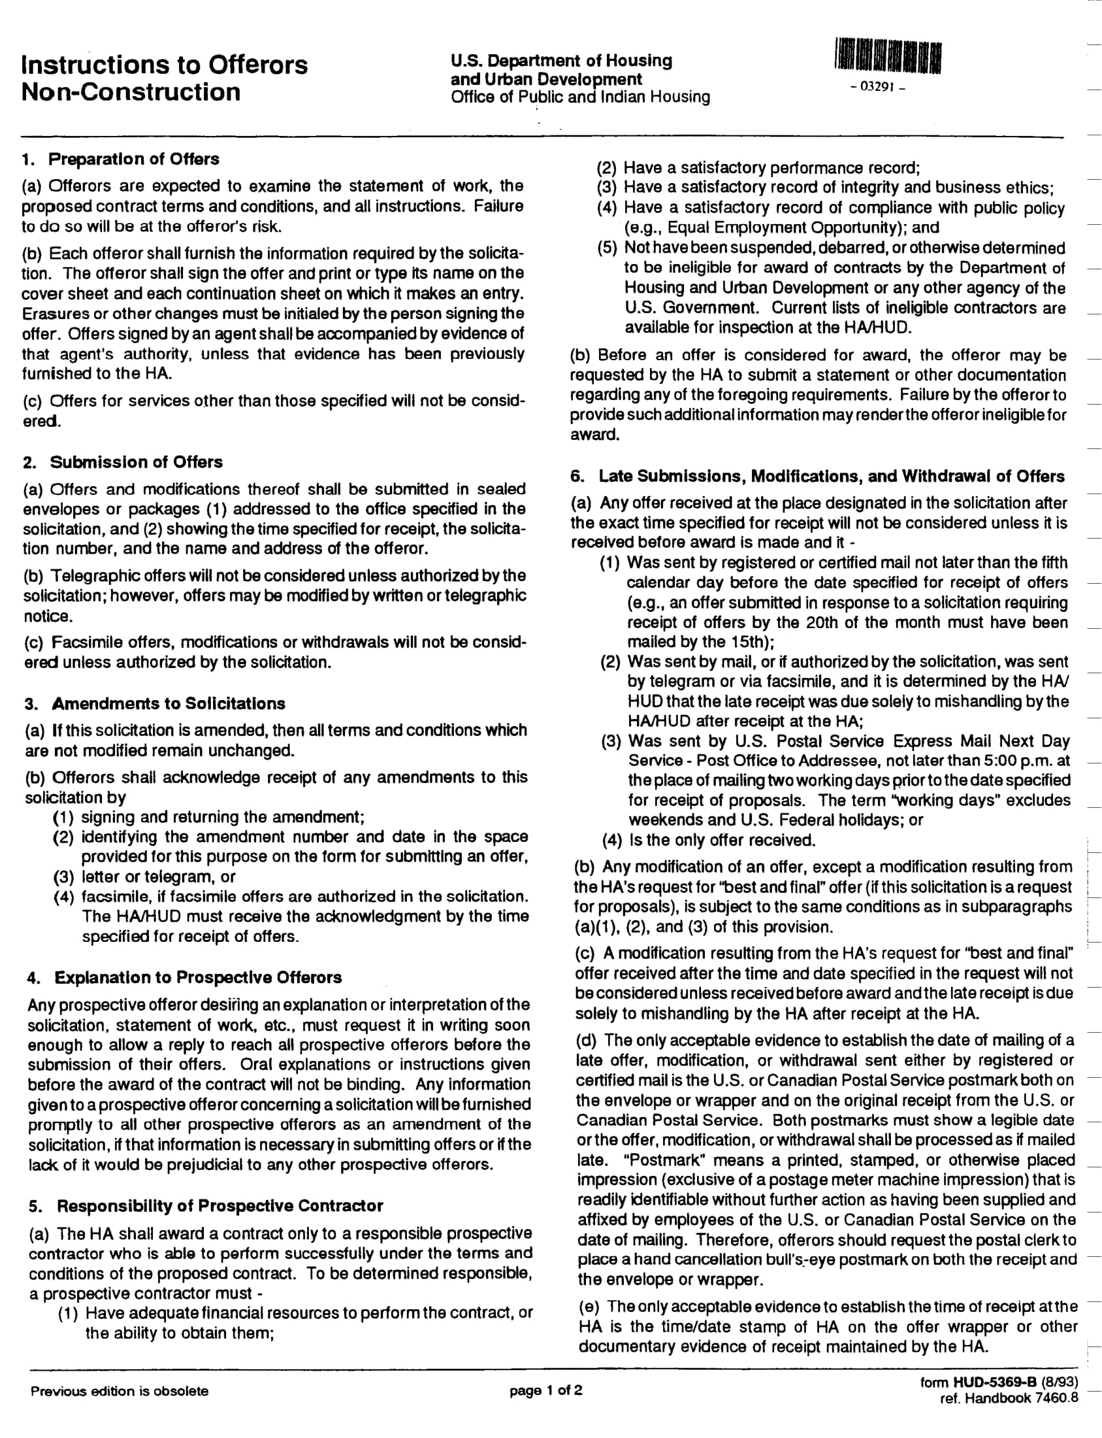

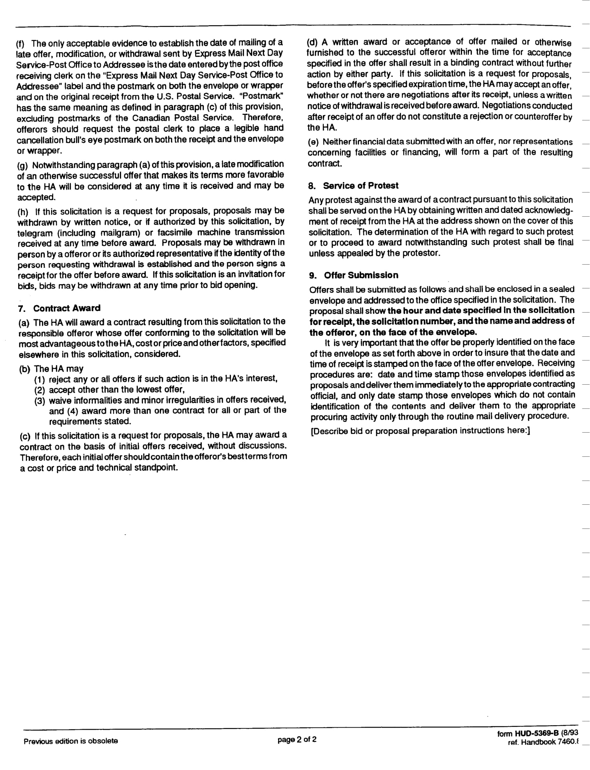

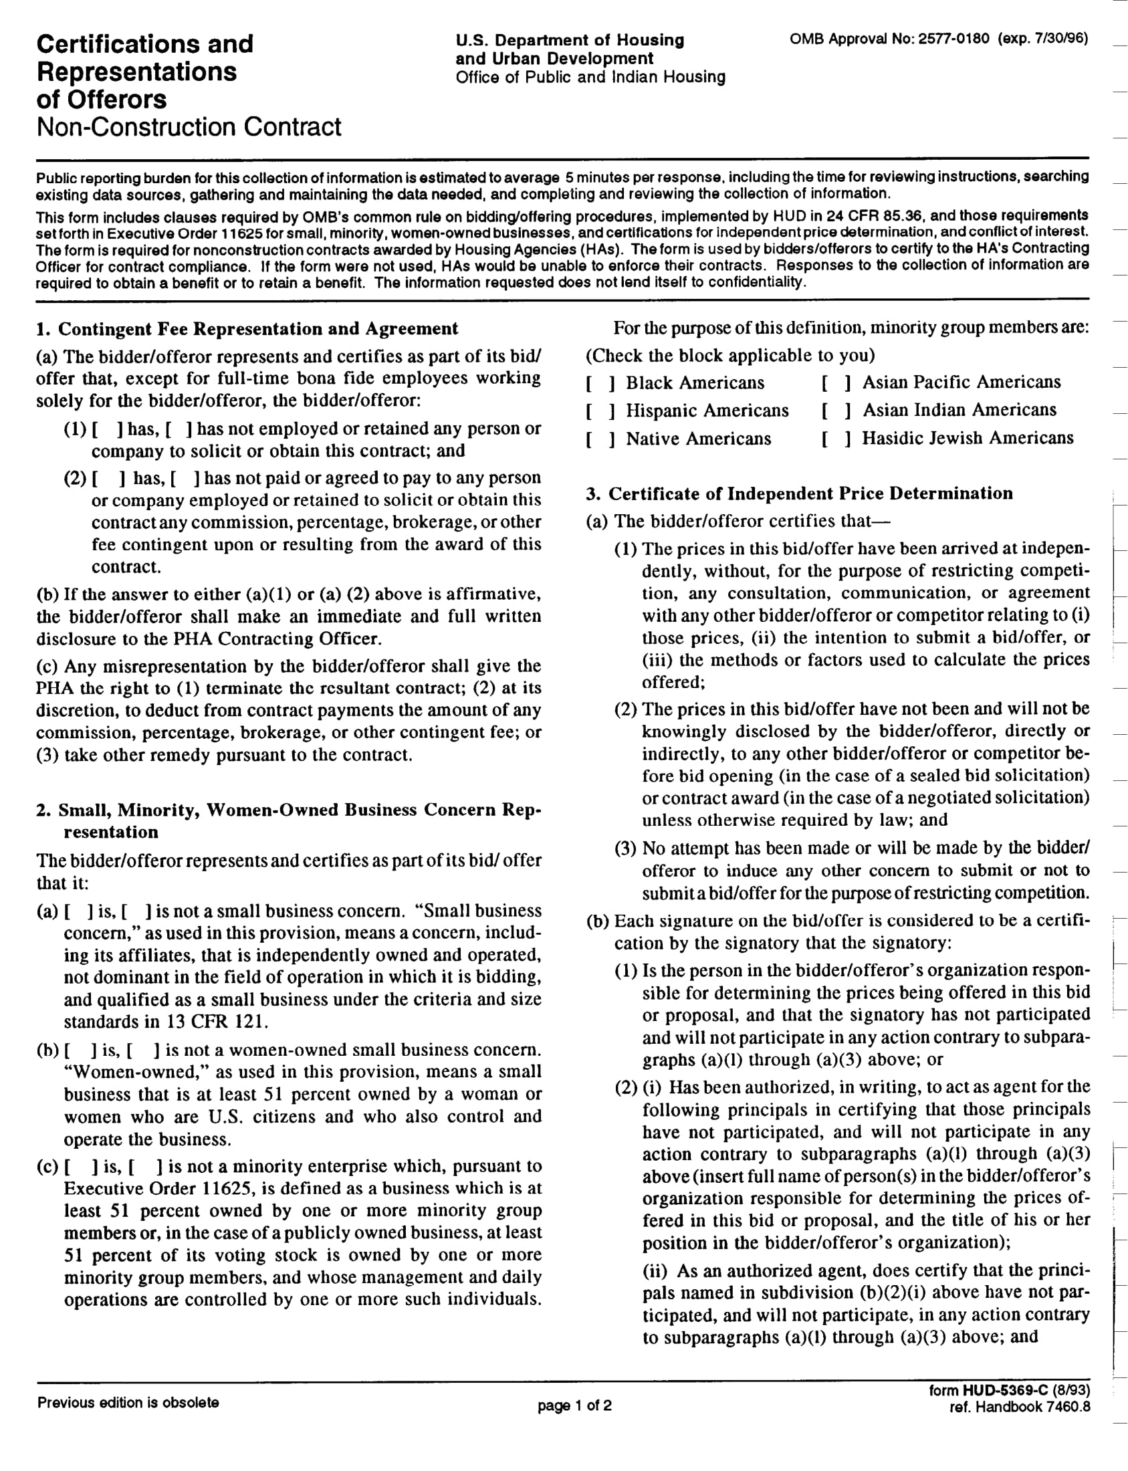

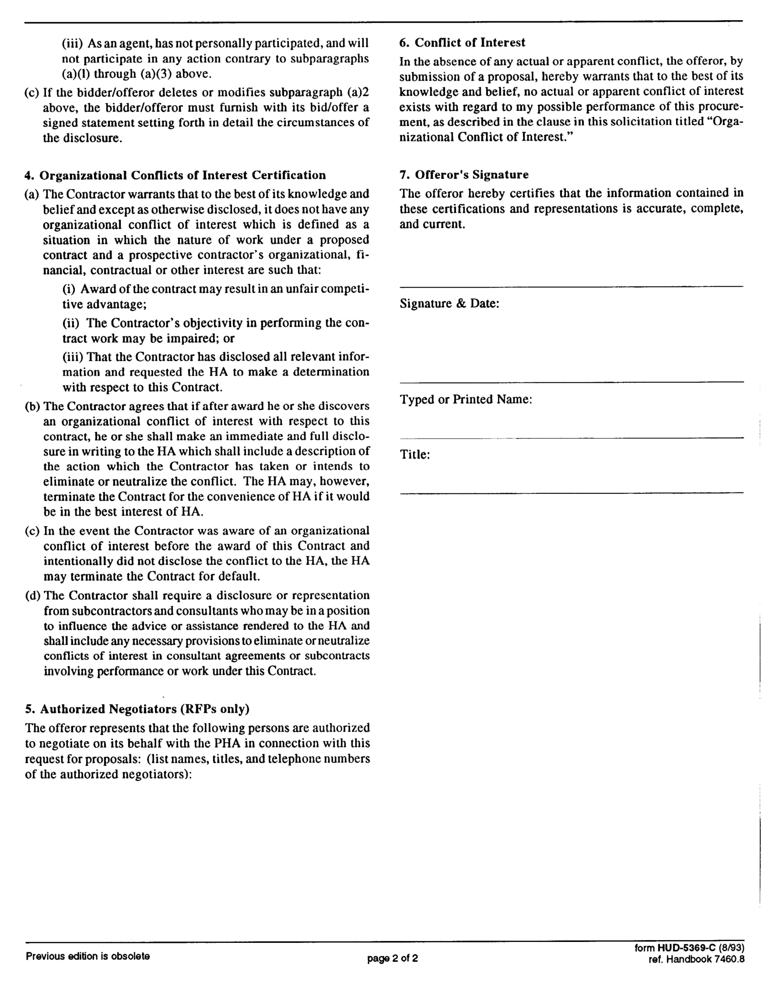

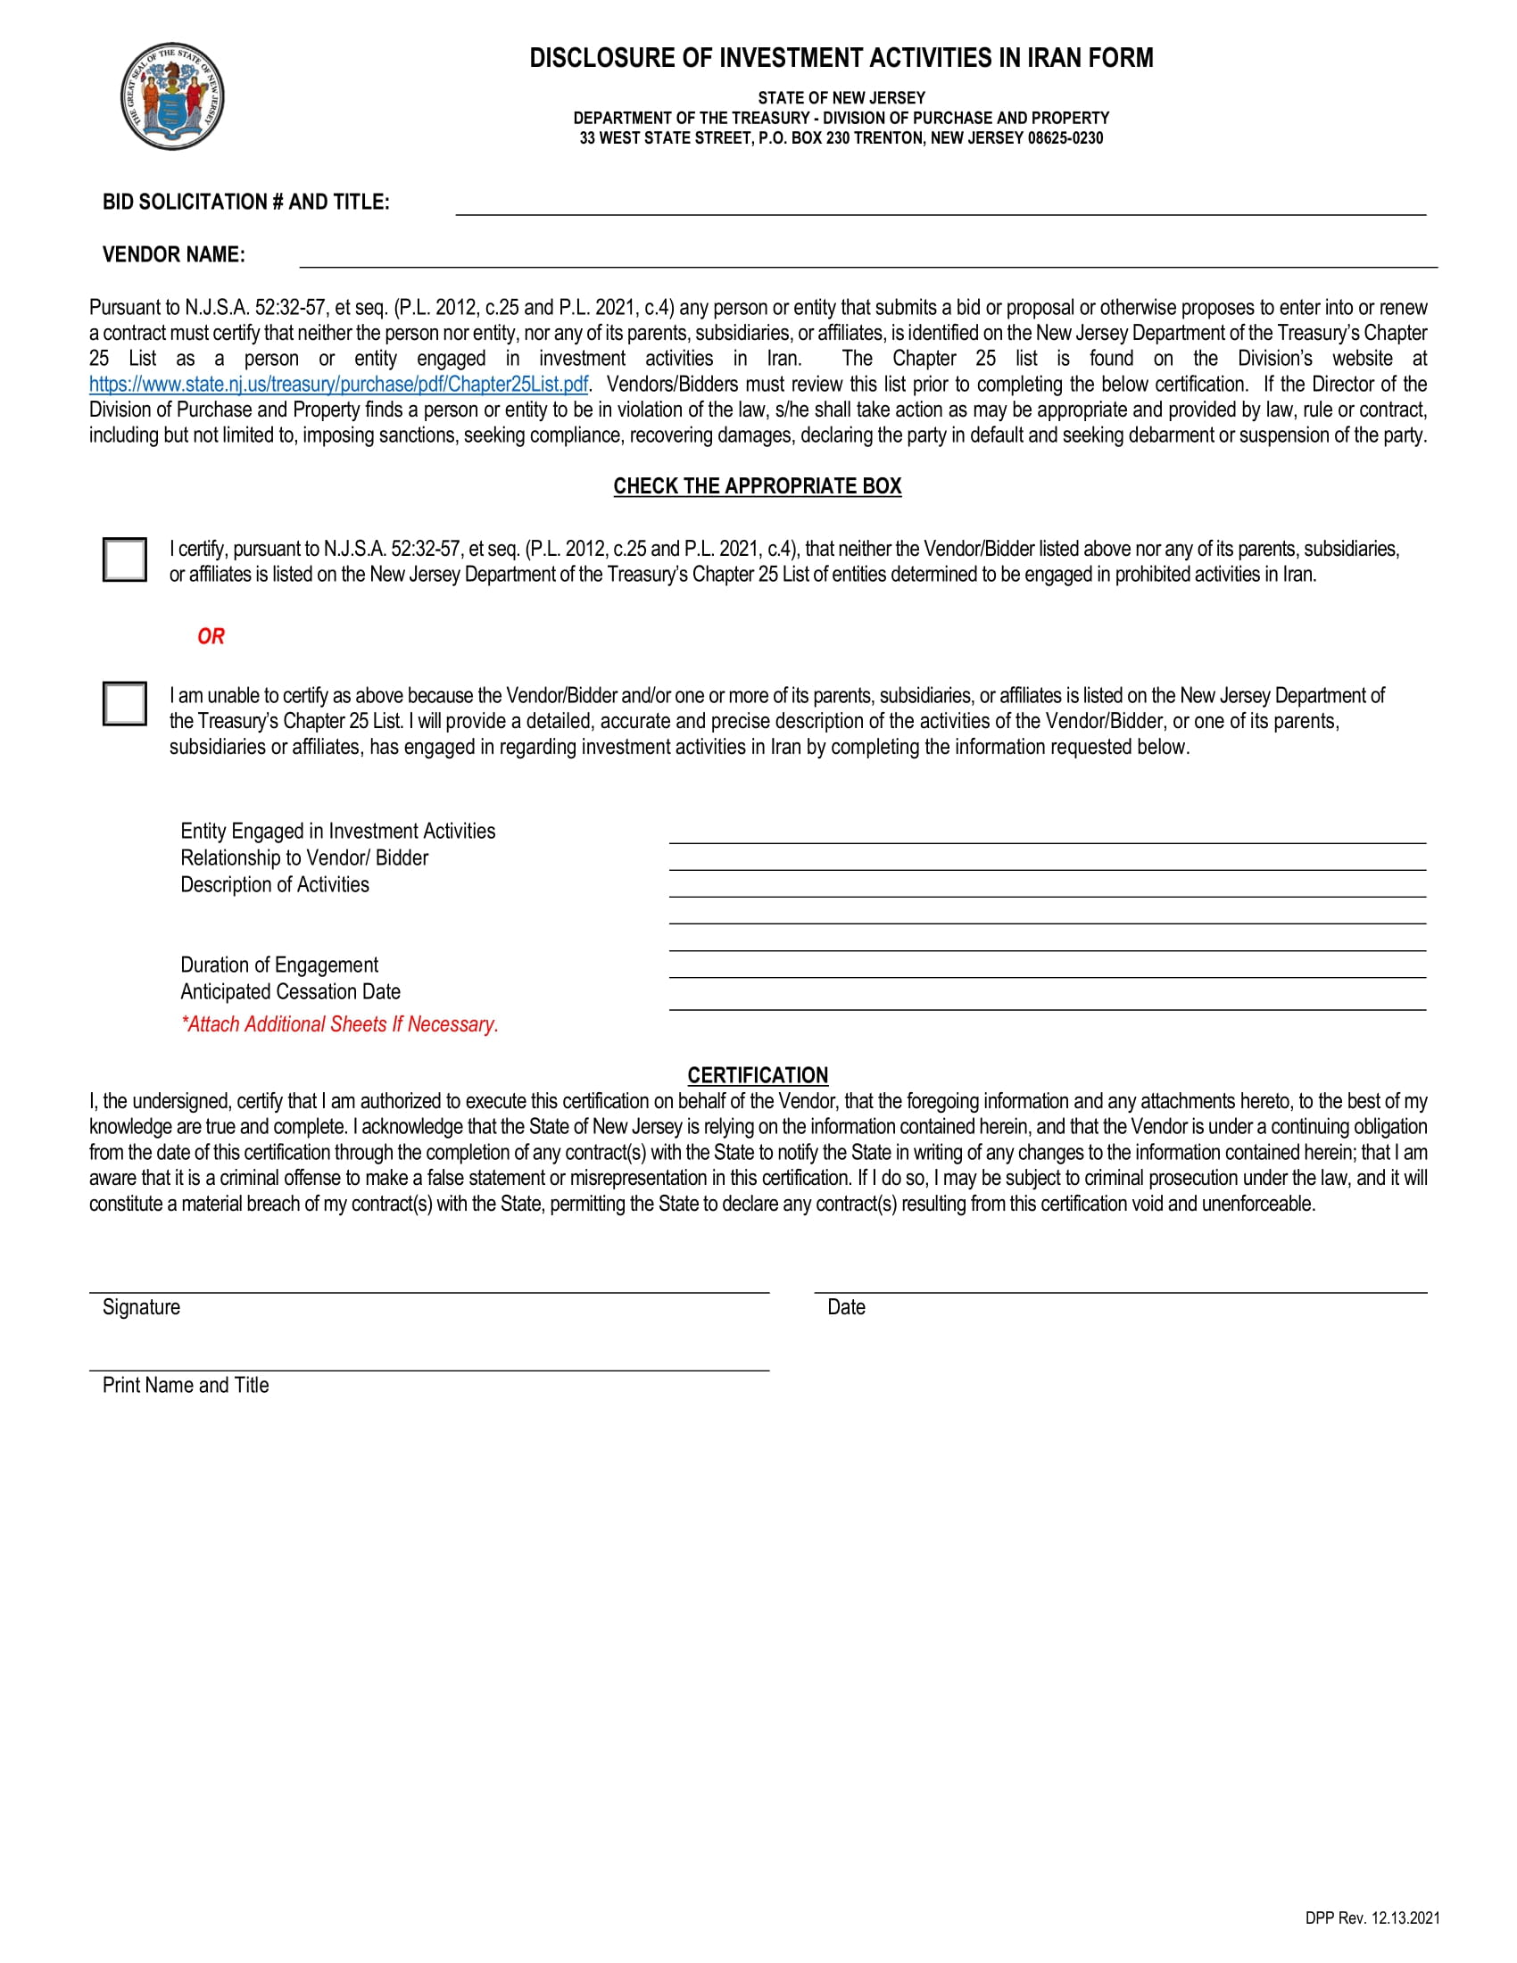

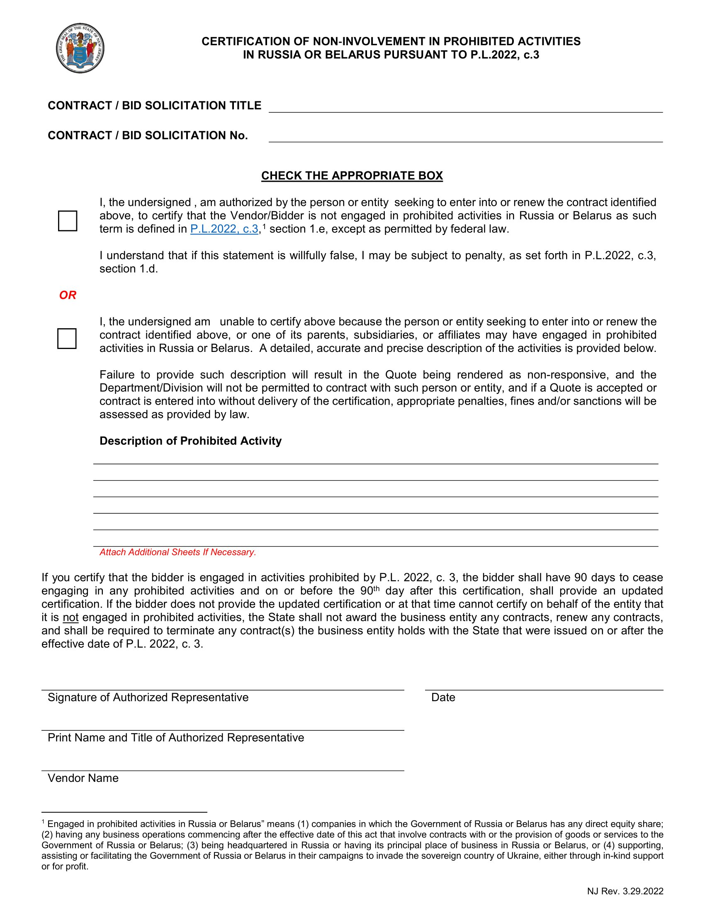
FORM OF CONTRACT

THIS AGREEMENT made on __________________, by and between the HOUSING AUTHORITY OF THE TOWN OF HARRISON, 788 Harrison Avenue, Building #1, Harrison, New Jersey 07029 (hereinafter called the “HOUSING AUTHORITY”) and _____________________________ (hereinafter called the “CONSULTANT”).
WITNESSETH, that the Housing Authority and the Consultant, for the consideration stated herein, agree as follows:

ARTICLE 1: Scope of Services. The Consultant shall provide the full range of services identified in the Housing Authority’s Request for Proposals and the Consultant’s proposal. The services shall be provided in a competent and professional manner, in accordance with prevailing professional standards and applicable Federal, State, and Local statutes, rules, regulations, ordinances, orders, and codes. The Housing Authority shall be entitled to a satisfactory performance of all Services and to full and prompt cooperation by the Consultant in all aspects of the Services. The Consultant shall be responsible for all damages arising out of or resulting from the Consultant’s performance under this Contract.
ARTICLE 2: Qualifications. The Consultant represents that its personnel have the proper skill, training, background, knowledge, experience, rights, authorizations, integrity, character and licenses as necessary to perform the services described herein in a competent and professional manner.
ARTICLE 3: Agreement Term. This Agreement shall be in effect for the one-year period commencing November 1, 2025 and ending October 31, 2025.
ARTICLE 4: Compensation. The Consultant’s compensation for the services provided according to the terms of this Agreement shall be ______________. The Consultant shall submit detailed monthly invoices to the Housing Authority which identify all services performed and contain a full cost breakdown for all such services. The invoices shall be reviewed for payment approval by the Housing Authority’s Executive Director.
ARTICLE 5: Insurance. The Consultant shall obtain and maintain adequate insurance coverage, as identified in the Housing Authority’s Request for Proposals, throughout the term of this Agreement. The Consultant must provide a Certificate of Insurance naming the Housing Authority as an additional insured. The Housing Authority shall be notified in writing at least thirty (30) days prior to any change in or cancellation of insurance coverage.
ARTICLE 6: Indemnification. The Consultant shall indemnify and hold harmless the Housing Authority and its Board, Commissioners, officers, directors, and employees from and against any and all claims, suits, actions, damages, losses and expenses, including but not limited to reasonable attorneys’ fees, arising out of or resulting from the Consultant’s performance under this Contract.
ARTICLE 7: Subcontracting. The Consultant shall be solely responsible for the performance of this Agreement. The use of a Subcontractor, except as approved in writing by the Housing Authority’s Executive Director, shall be prohibited. Approval of a subcontractor shall be granted in the Housing Authority’s sole discretion. Substitution of a subcontractor without the Housing Authority’s written approval is prohibited. Any use of a Subcontractor in violation of this provision shall be deemed a material breach of this Agreement.
ARTICLE 8: Independent Contractor Relationship. The Consultant is, and shall be, in the performance of its obligations under this Agreement, an independent contractor, and not an employee, agent or servant of the Housing Authority. All persons engaged in any of the services performed pursuant to this Agreement shall at all times, and in all places, be subject to the Consultant’s sole direction, supervision and control.
ARTICLE 9: Termination for Convenience. The Housing Authority may terminate this Agreement, in whole or in part, by delivering to the Consultant written notice ten (10) business days prior to any effective termination date. The Notice of Termination shall specify: 1) that the termination is for the convenience of the Housing Authority; 2) the extent of the termination; and 3) the effective date of the termination. In the event of a termination for convenience hereunder, the Housing Authority shall pay the Consultant for services rendered through the date of termination.
ARTICLE 10: Termination by Default. This Contract may be terminated if there has been a material default in the performance or observance of any term or condition herein by the Consultant. The failure to perform any of the following shall constitute an event of default: 1) failure to satisfactorily and timely perform any or all of the services specified herein; 2) discontinuation of services without authorization or justification; 3) failure to maintain adequate insurance coverage; 4) failure to comply with applicable legal requirements; and 5) suspension from participation in any federal or state government programs. The Housing Authority may, in its discretion, elect not to declare a default or to terminate the contract, but such election shall not constitute a waiver by the Housing Authority of its right to pursue any or all available legal remedies, nor shall Consultant be relieved of any of its responsibilities, duties or obligations under this Contract.
ARTICLE 11: Prevailing Law. This Agreement shall be governed by and construed in accordance with the laws of the State of New Jersey without reference to choice of law principles. Any and all disputes arising out of or related to this Agreement, or the services provided hereunder must be brought in the Superior Court of New Jersey, Hudson County.
ARTICLE 12: Non-Debarment. By execution of this Agreement, the Consultant certifies that it is not currently debarred by the Federal government, including the U.S. Department of Housing and Urban Development or any other Federal agency, the State of New Jersey, or any State agency.
ARTICLE 13: Confidentiality. All Services performed and provided under this Agreement, and other materials, data, transactions of all forms, financial information, documentation, inventions, designs and methods obtained from the Housing Authority in connection with the Services performed under this Agreement, made or developed by the Consultant in the course of the performance of such Services, or the results of such Services, or for which the Housing Authority holds the proprietary rights, constitutes confidential information (“Confidential Information”) and may not, without the prior written consent of the Housing Authority, be used by the Consultant for any purpose other than for the benefit of the Housing Authority, unless required by law.
ARTICLE 14: Non-Discrimination. The Consultant agrees not to discriminate against any employee or applicant for employment because of race, religion, color, sex, sexual orientation, handicap, marital status, age, national origin or status as a veteran of the United States military, and to take affirmative action to ensure that they are afforded equal employment opportunities without discrimination. Such action shall be taken with reference to, but not limited to, recruitment, employment, termination, rates of pay or other forms of compensation, and selection for training or retraining, including apprenticeship and on the job training.
ARTICLE 15: Conflicts of Interest. The Consultant represents that it does not presently have any interest and will not acquire any interest, direct or indirect, which would conflict in any manner or degree with the performance of its obligations under this Agreement.
ARTICLE 16: Assignment. The Consultant shall not assign, transfer, convey, or otherwise dispose of this Agreement, including its rights, title, or interest in or to the same of any part thereof without the prior written consent of the Housing Authority. Any purported assignment without the prior written consent of the Housing Authority shall be void and unenforceable.
ARTICLE 17: Severability. If this Agreement contains any provision found to be unlawful by a court of competent jurisdiction, the same shall be deemed to be of no effect and shall be deemed stricken from this Agreement without affecting the binding force of this Agreement as it shall remain after omitting such provision.
ARTICLE 18: Counterparts. This Agreement may be executed in any number of counterparts, each of which shall be deemed an original, but all of which shall together constitute one and the same instrument.
ARTICLE 19: Integration. This Agreement and the Housing Authority’s Request for Proposals shall constitute the entire agreement and understanding of the parties hereto with respect to the subject matter contained herein, and supersedes all prior agreements, promises, covenants, arrangements, communications, representations or warranties, whether oral or written, by any officer, employee or representative of any party hereto.
ARTICLE 20: Subsequent Modification. This Agreement may not be changed or modified except by written agreement specifically referencing this Agreement and executed by each of the parties hereto.
ARTICLE 21: Effect of Headings and Titles. The headings and titles used in this Agreement are solely for convenience of reference and shall not affect its interpretation or construction.
ARTICLE 22: No Interpretation Against Draftsman. This Agreement shall be construed without regard to any presumption or other rule requiring construction against the party causing this Agreement to be drafted.

IN WITNESS WHEREOF, the parties hereto have caused this instrument to be executed the date and year first written above.

HOUSING AUTHORITY OF THE TOWN OF HARRISON

Dated: ____________ _________________________________
Raymond Lucas, Executive Director

[CONSULTANT]

Dated: ____________ _________________________________
[name], [title]

